**Part 4**

**Step 1: Importing Packages**

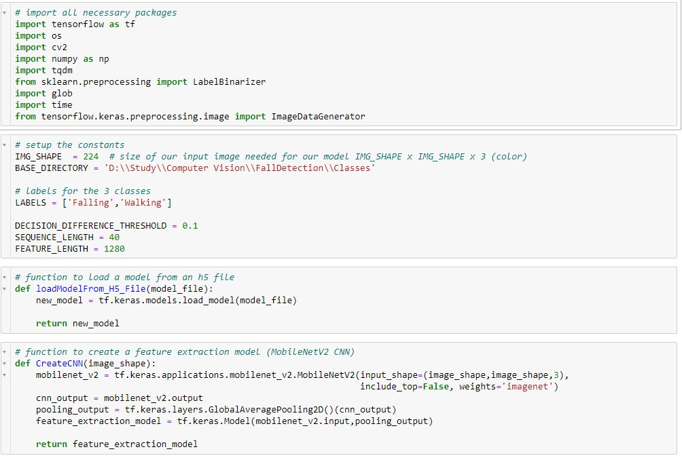

**Step 2: Extracting all the features from a list of properly sized images**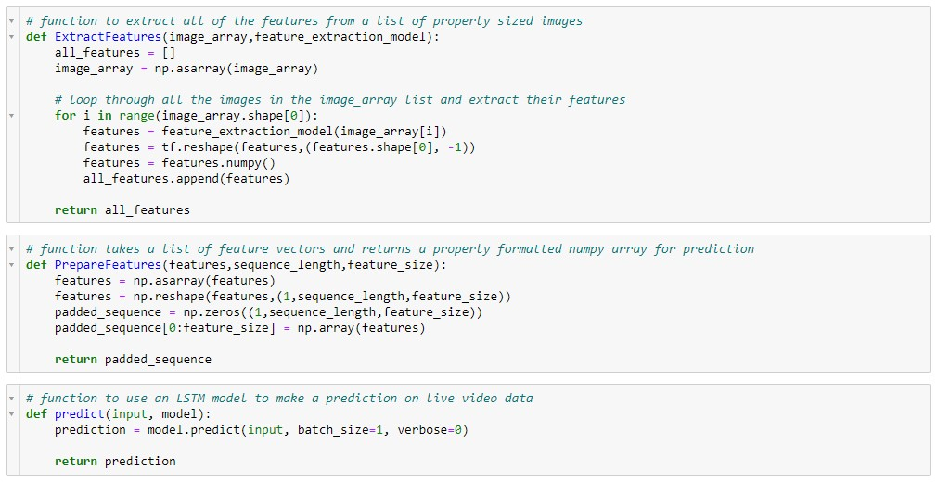

**Step 3: Function to make a classification decision and return a label**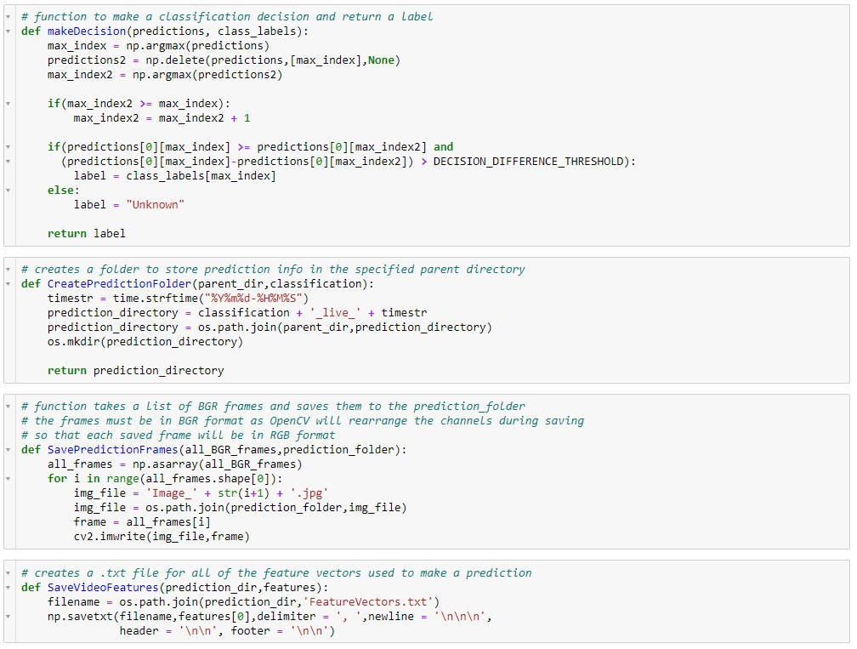

**Step 4 : Creating .txt file for all of the feature vectors used to make a predicti**